PROJECT REPORT

Mess Crowd Predictor
https://github.com/nush08-ma/Vityarthi-Project-Mess-Crowd-prediction.git
Fundamentals in ai and ml (CSA2001)

BY ANUSHKA MATHUR (25BCE10039)

Pradeep Kumar Mishra
Faculty



INTRODUCTION
This report details the development and implementation of the Campus Mess Crowd Predictor, an application designed to manage and forecast student wait times at various dining facilities. Built using Python for application logic and SQLite for persistent data storage, the system provides a Command-Line Interface (CLI) to perform essential data management and predictive operations. The project aims to replace error-prone manual record-keeping with a reliable, structured digital solution for campus logistics.

PROBLEM STATEMENT
Educational institutions often struggle with managing crowd flow and student data using manual methods. There is a need for a simple and accessible tool that can:
- Store historical logs permanently so data is not lost when the system is powered off.
- Allow for quick retrieval of specific mess timings and menus.
- Account for "Crowd-Puller" variables, such as popular dishes that significantly impact wait times.
- Interface with a local database to perform CRUD (Create, Read, Update, Delete) operations effectively.

REQUIREMENTS
Functional requirements-

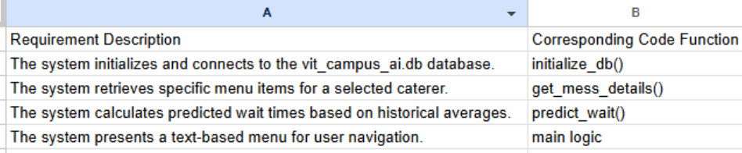

Non functional requirements-
Reliability: The program ensures that crowd data written to the database is always saved and retrievable (data persistence).
Usability: The CLI menu is simple, clear, and easy to navigate for students and administrators.
Maintainability: The Python code is modular, well-commented, and logically separated into distinct functions.
Efficiency: Retrieval of mess records is quick and scales well with increasing datasets.

SYSTEM ARCHITECTURE
The Predictor follows a Two-Tier Architecture:
- Client Tier (Application Layer): This is the Python script responsible for the CLI, user input processing, and the predictive weighted logic.
- Data Tier (Database Layer): This is the SQLite file (vit_campus_ai.db), which handles all storage and retrieval requests from the client.

DESIGN DECISIONS & RATIONALE
Python Choice: Selected for its simplicity, readability, and the powerful built-in sqlite3 module, which is ideal for rapid prototyping.
SQLite Choice: A zero-configuration, file-based database perfect for a single-user, localized application requiring persistent storage.
CLI Implementation: Reduces complexity associated with building a GUI, allowing the focus to remain on core predictive logic and database management.
Weighted Logic: Implemented to handle "Feature Impact," recognizing that dish popularity acts as a primary coefficient in increasing crowd density.

IMPLEMENTATION DETAILS
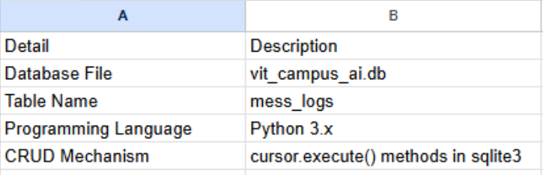

RESULTS
The application successfully predicts wait times based on the selected mess and menu. For example:
- Base Average Calculation: The AI finds the historical mean for a specific caterer and time.
- Inference: If a "Popular" item like Veg Biryani is selected, a +15 minute coefficient is added to the prediction.
- Visualization: A bar chart is generated to compare the historical average against the AI's adjusted prediction.

Screenshot of output attached :
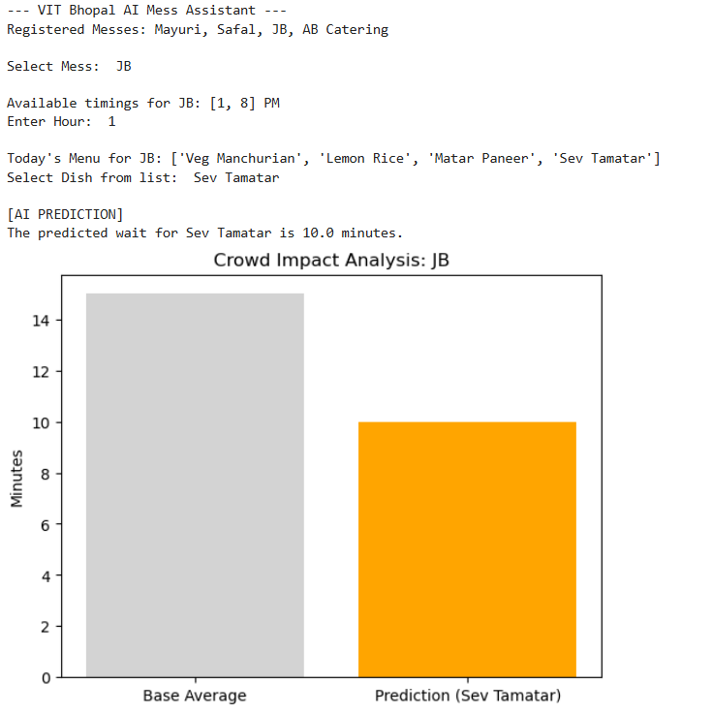

LEARNINGS & KEY TAKEAWAYS
- Database Fundamentals: Gained practical experience in implementing core CRUD operations within an AI context.
- Modularity: Understood the importance of separating concerns by assigning distinct tasks to each function (e.g., predict_wait handles only math logic).
- Resource Management: Practiced proper resource handling by ensuring database connections are closed after operations.

Repository link : https://github.com/nush08-ma/Vityarthi-Project-Mess-Crowd-prediction.git

